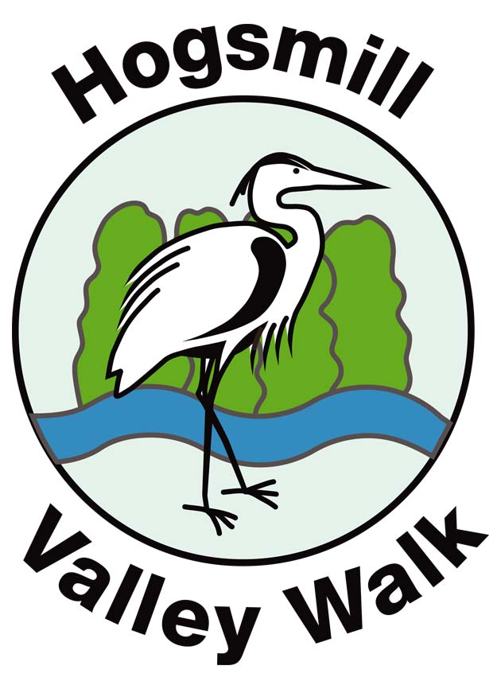
Hogsmill Action Group
Do you have a spare couple of hours to help conserve the picturesque Hogsmill Valley Walk?

Volunteers are needed to clear the pathways of brambles, nettles and tree roots at Oak Tree Walk and The Hollows.

All equipment such as secateurs and gloves will be provided along with refreshments.

Please ensure you are wearing protective clothing (the nettles are quite spiteful) and strong shoes/boots or Wellingtons as the ground may be boggy underfoot.

Come and join in the fun! Give yourself an appettite for your Sunday lunch!
Conservation/Cleanup Day

Sunday 19th October 2008

Meeting at the junction of Southwood Drive and Knollmead, Surbiton
at 10am
For further details please call the
Environmental Services, Contact
Centre on telephone: 020 8547 5929.

