The Kingston Team Ministry
St John the Evangelist

www.stjohnskingston.co.uk

_______________________________________________________________________________________

St John’s Church and Hall
There has been a lot of interest in the consideration that St John’s Church has been giving to its responsibilities as owners of the two significant community spaces - the church and hall - on Grove Lane. In particular, many people are concerned that the possible sale of the hall has been allowed to be part of that thinking and there is unease about the perceived loss of facilities and services. This paper sets out the actual position and indicates some of the complexities around the issue.

The current position
The church has been engaged in a feasibility process, to consider its redevelopment, for two reasons. Firstly, it has needs concerning light, heat and access which, if left unaddressed, will result in it becoming unusable and, secondly, as the largest and most prominent community space in the neighbourhood it presents a significant opportunity to provide residents of the area with the facilities that could greatly enhance communal life. Given that redevelopments are best treated in a coherent fashion this wider potential has been part of the thinking about how best to proceed.

The cost of the restoring essential heat, light and appropriate access is in the region of £500,000 with the wider work costing about £1.5 million (though a scaled down version of this could be achieved for about £1 million). However, a realistic assessment of the situation needs to recognise that fundraising for heating and lighting on its own is traditionally difficult because funders are reluctant to give for these elements without their association with other community benefits. So, breaking the project down into smaller elements is not necessarily as simple as it may seem.
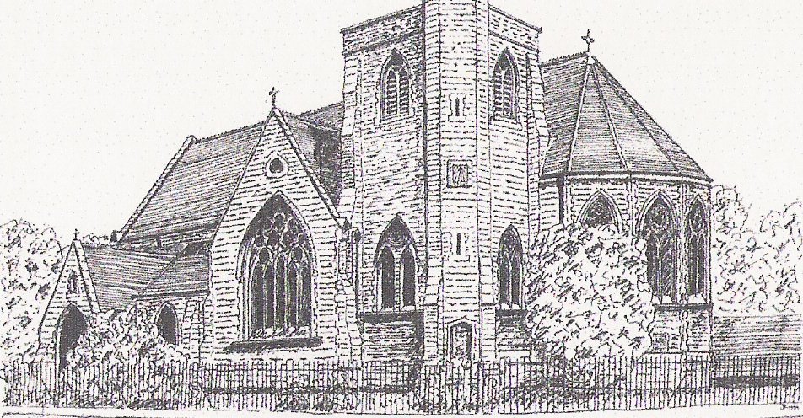

Team Rector Kingston Team
Rev Jonathan Wilkes
15 Woodbines Avenue
KT1 2AZ
020 3132 8717 ask902@googlemail.com

These sums are, clearly, very large. What the church has been doing, as anyone trying to address a problem sensibly would do, is to have an open mind about exploring all of the options that are open to it. Among these has been to investigate the fundraising potential that it has from grant making trusts and other bodies, explore possible partnerships with other Kingston institutions like the St John’s Church School, Kingston University and College and assess how much money might be raised or gifted from within the Church congregation and through Church fundraising events.

However, one other option has been to consider whether the capital sum that is tied up in the value of the Church Hall might be better deployed in ensuring that the Church can remain open and allow the large, prominent space in the heart of the community to be put to better use.
At this point we should say - as we have done consistently since this first became a matter of public discussion - something very important; that this is only one of a number of options and that it is NOT felt by the church to be the preferred course of action. Why would it be? - the Church of England has a long history of serving communities effectively through its buildings of various kinds. We know the value of community space and aren’t considering this option lightly or as an easy way out. We know that the hall is valued and used and we have supported that use over the 100 years of its life so far, in particular in recent years through providing the space for the community to use at very modest rates of hire for things like performances or Kingston Kindergarten.

As we’ve said clearly before in other places, no decision has been taken about this yet. What we’re engaged in is a period of careful, broad minded and rational consideration of what might be in the best interests of the community at large.

Part of that reflection is to recognise the importance that the church has for the community and the opportunity its redevelopment offers the people of the area. Though sometimes unobtrusively, the church plays an important part in the life of the neighbourhood. It contributes to the local school in a variety of ways not least through supporting admissions, as a place for school events and helping with governance. It provides the ongoing presence of a paid professional worker in the neighbourhood (the church Vicar) who offers pastoral support to people regardless of whether they are church goers or not. It is used by a wide range of groups for music making, meeting and education. All this without mentioning at all that people like to pray there, have their children baptised, get married or bury loved ones.

However, perhaps the most significant question is to ask how the neighbourhood would feel if the church were a block of flats or student accommodation. Pub, school, shops, church, these are the things that sustain a sense of community (not to mention, give value to our property prices). To lose the largest, most prominent community space to some kind of a commercial outlet would affect us all. Very clearly, lots of people and lots of groups work hard locally to make life better for those living here but the church - and its building - plays its part in that and is an asset to be preserved.

We don’t wish to overstate the threat that exists to its survival. St John’s is supported by a lively, thriving and committed congregation that will work hard to support it and maintain its function, but neither are we unrealistic or dismissive of the realities involved here. When heat and light cease to work buildings become unusable and there are scores of examples around the country of grade 2 listed churches that have kept their facade but changed their use, and the result for the surrounding community is not positive.

The church has value to the neighbourhood as it stands but is a site of great potential. There are many examples of large church buildings like ours being used for a variety of different purposes that enhance its central role as a place of worship (an example of one such church can be found at http://www.stpauloldford.com/history-vision/st-pauls-five-years-on/). We are using our time, energy and resources to explore how we can best develop it for the benefit of the people who live here. Again, the church is the largest and most prominent communal space in the neigbourhood and it would seem sensible for it to have the facilities to be as useful as possible (to include ensuring that current uses of the hall are replicated).

Possible ways forward
No decision has been reached yet about what the church feels is the best way to take forward the two community spaces it is responsible for. If it decides that selling the Hall is not the right thing to do then it will continue to manage the space and will seek to develop its use for the benefit of a wide range of people. However, as has been stated before, if, after careful consideration, the church comes to the mind that selling the hall is the right thing for the wider community in the long run then the next stage in this process will be to invite a wider discussion through a consultation within the local area.

But this isn’t where we are yet and it has not seemed sensible to consult formally on something that may not, ultimately, be pursued. It is hoped that within three months we will have a clearer idea of what we feel is the right way forward and we will communicate that widely as soon as we can.

