
A unique concert in a candlelit

church showcasing some of the

country’s finest contemporary

acts with an extra special guest

appearance by Kate Walsh,

No 1 album artiste on itunes

Now in its third year, Christmas Unsigned comes to St John’s Church in Kingston on Saturday 6th December with a simply unmissable show featuring :
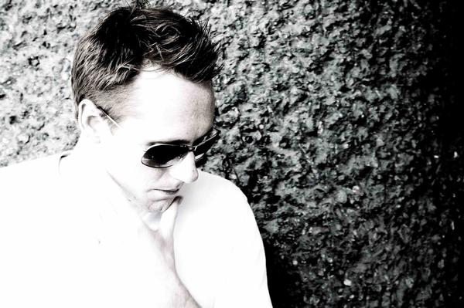

ANDREW MORRIS

Andrew Morris is a gifted songwriter, compelling vocalist and consummate live performer. A criminal lawyer by day, Andrew was born in Australia but now resides in Surbiton. It might not be Sydney but it’s a lot handier for Waterloo. Andrew released his first EP, Upside Down, last year and the title track was included on iTunes Essentials compilation, Hotly Tipped for 2008 along with names like Duffy, Adele and The Ting Tings.

Winner of the Playmusic best solo artist unsigned award, Andrew appeared at Glastonbury this summer and recently supported rock legends Marillion at the band’s invitation. Andrew will be appearing with his excellent backing band and can be previewed at
www.myspace.com/andrewmorrismusic

KATE WALSH
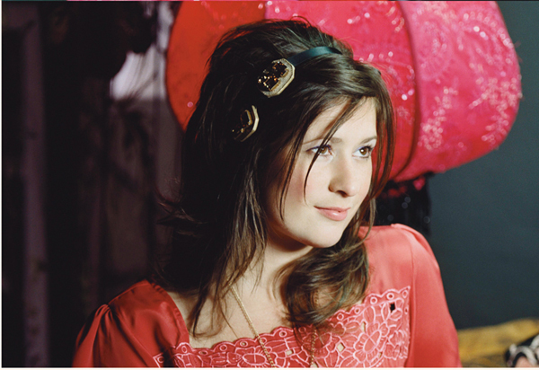
We are delighted that Kate Walsh will be making a guest appearance. Kate was the first unsigned artiste to top the itunes UK album chart when her ‘home-made’ album, Tim’s House, kept luminaries like Elton John and Take That at bay! A soothing, richly sensual work, Tim’s House is packed with heart-stoppingly beautiful songs - if ‘Your Song’ and ‘Tonight’ don’t move you we suggest you check your pulse with some urgency! The album has maturity and finesse way beyond Kate’s years. Christmas Unsigned will be Kate’s first live date since her US tour finished in the summer, since when she has been recording her new album for release next year. Kate will be previewing some songs from the new record together with some old favourites. Listen to Kate at www.myspace.com/katewalsh

fish!

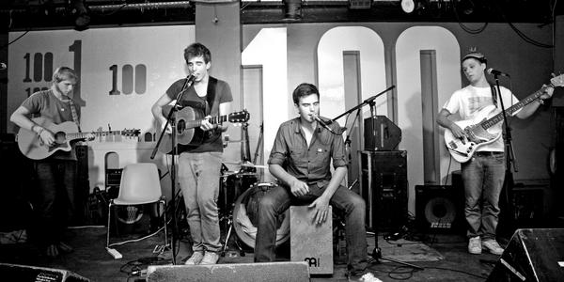
Completing the line-up are fish!, a great young four-piece band from Kingston who are now getting rave reviews for their live shows at London landmarks such as the Troubadour and 100 Club. Fish! write and perform their own songs, peppered with memorable melody lines and thoughtful lyrics. The band will be performing a special ‘unplugged’ set (or should that be ungrilled?!) Meanwhile you can get a taste for fish! at www.myspace.com/fishuk

The beneficiary

Proceeds from Christmas Unsigned will be going to the St John Eye Hospital in Jerusalem. The hospital is the main eye care provider in the West Bank, Gaza and East Jerusalem. It is a charity which both St John’s Church and school have supported in the past, paying for several patients to be treated. The hospital urgently needs funds and has launched a £150,000 appeal to help its efforts in this troubled region.

Tickets

£10 in advance only (£6 concessions – under 18, students, over 65)

Further information

Please contact Tony Hardy at fifty3 on 07802 381130 or via tonyhardy@fifty3.net




